One To Many Uni-directional:

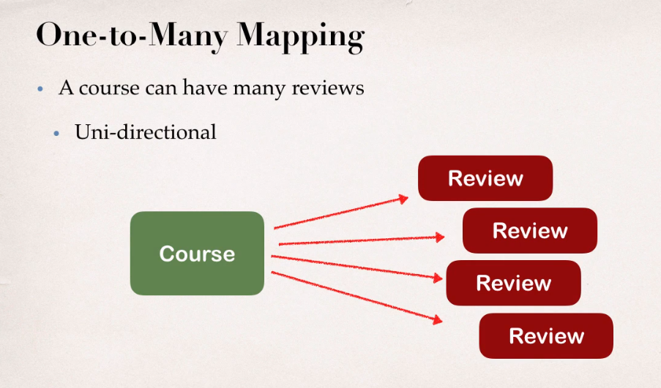

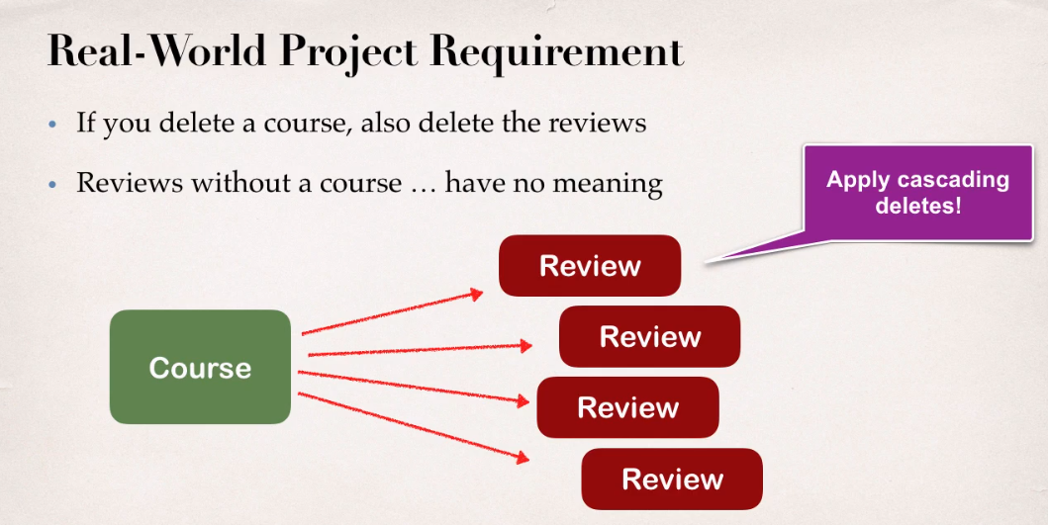

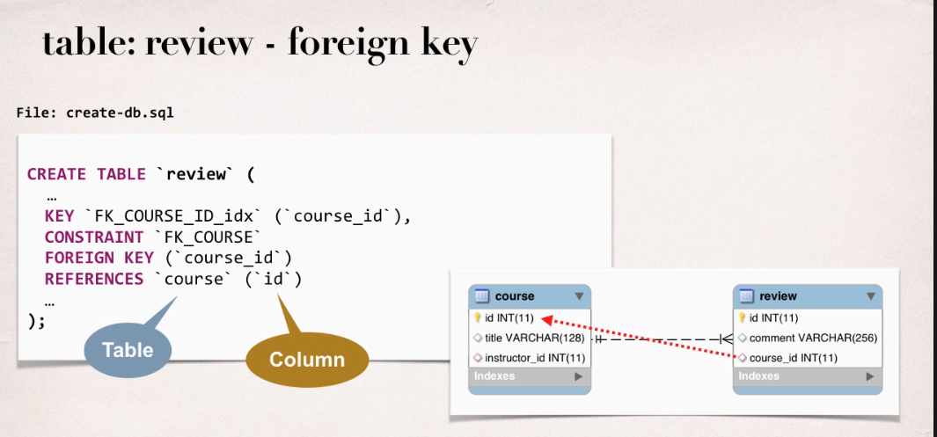

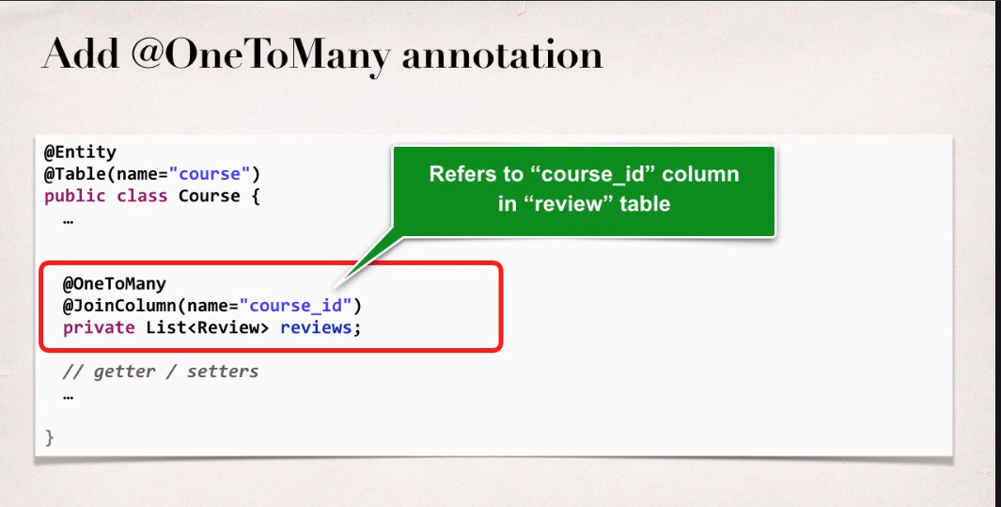

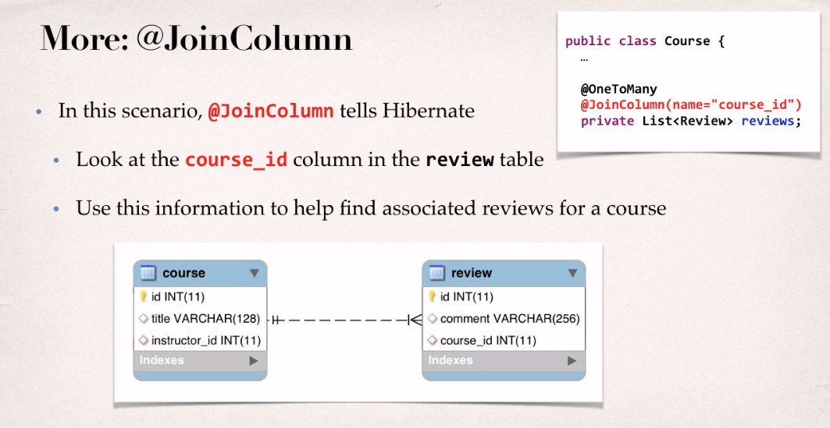

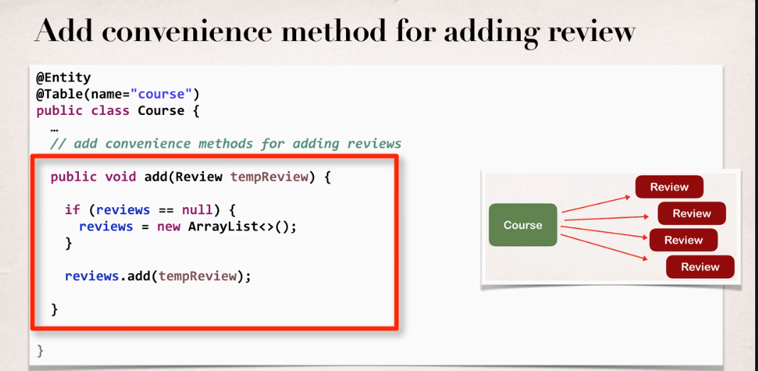

**@JoinColum ... where does it find the column?**

The JoinColumn is actually fairly complex and it goes through a number of advanced steps to find the desired column.

Check link:

http://docs.oracle.com/javaee/7/api/javax/persistence/JoinColumn.html#name

The table in which it is found depends upon the context.

- If the join is for a OneToOne or ManyToOne mapping using a foreign key mapping strategy, the foreign key column is in the table of the source entity or embeddable.

- If the join is for a unidirectional OneToMany mapping using a foreign key mapping strategy, the foreign key is in the table of the target entity.

- If the join is for a ManyToMany mapping or for a OneToOne or bidirectional ManyToOne/OneToMany mapping using a join table, the foreign key is in a join table.

- If the join is for an element collection, the foreign key is in a collection table.